Gabriel Oliver and Kevin Huang

CSS 432

Term Project: Implementing and Testing TFTP

## Completed Steps: Steps 1 through 6 have been completed.

## Incomplete Steps: All steps have been completed.

## Known bugs:

## Screenshots:

**Reading a small file:**

Server:

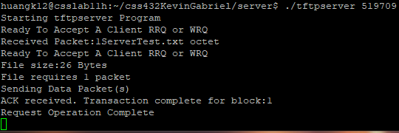

Client:

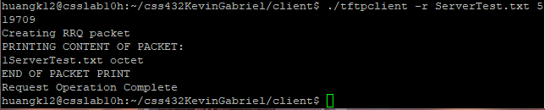

**Writing a small file:**

Server:

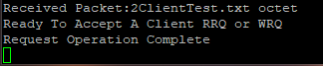

Client:

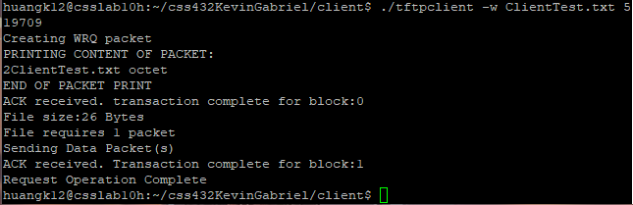

**Reading a large file:**

Server:

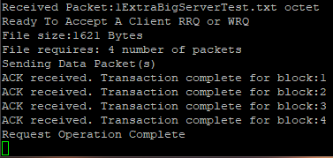

Client:

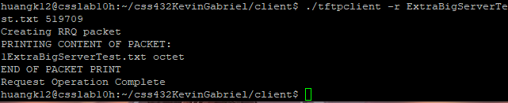

**Writing a large file:**

Server:

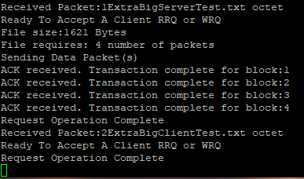

Client:

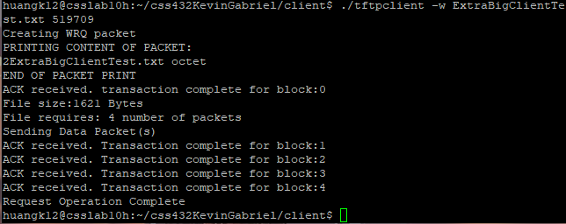

## Additional screenshots – timeouts, errors, and multiple requests:

**Transmission terminated after 10 timeouts due to server was killed:**

Server:

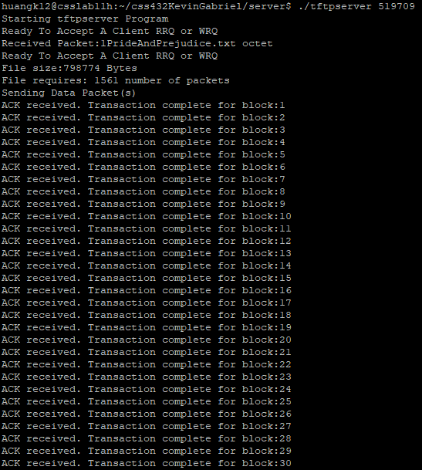

*Screenshots for blocks 31 – 839 not provided *

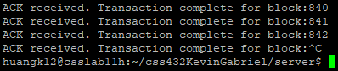

Client:

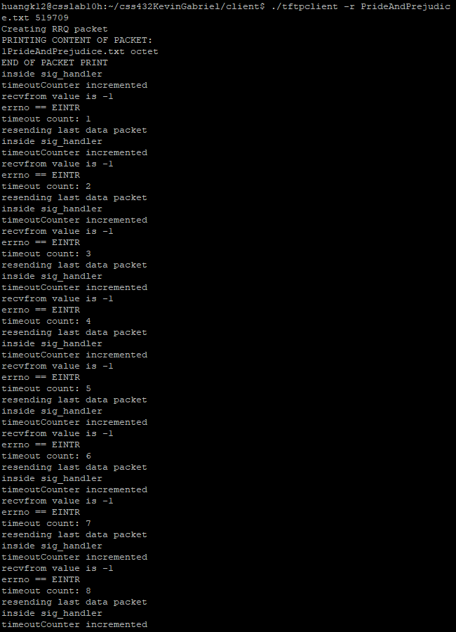

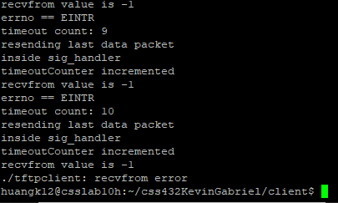

**Transmission terminated after 10 timeouts due to client was killed:**

Server:

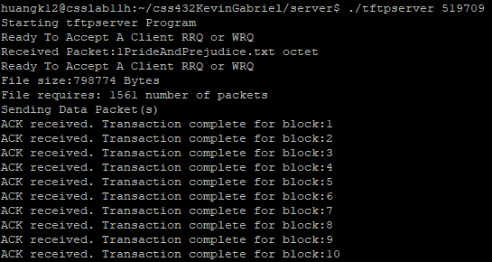

*Screenshots for blocks 11 – 994 not provided *

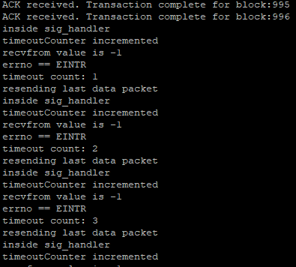

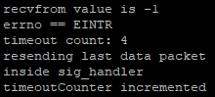

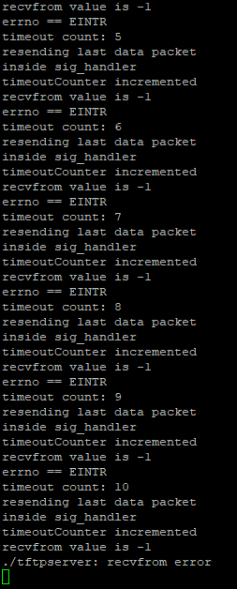

Client:

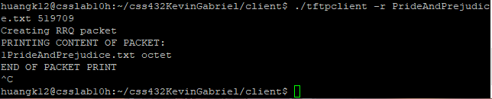

**Error cases:**

**File does not exist:**

Server:

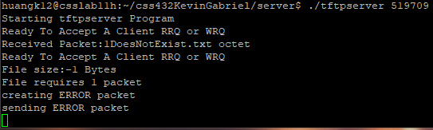

Client:

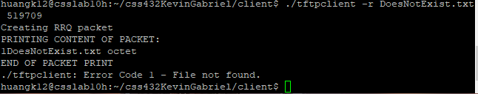

**File already exists (overwrite warning):**

Server:

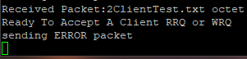

Client:

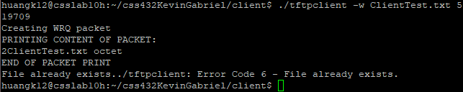

**No permission to access the requested file:**

Server:

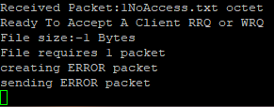

Client:

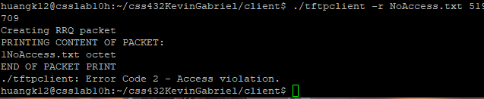

**Simultaneously read a file and write a different file:**

Server:

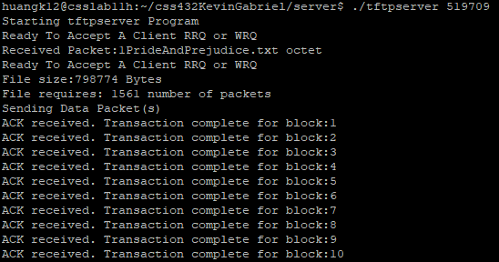

*Screenshots for blocks 11 – 548 not provided *

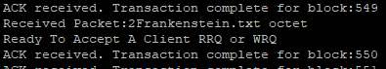

*Screenshots for blocks 551 – 1559 not provided *

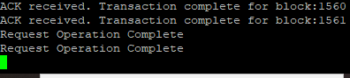

Client 1 (RRQ):

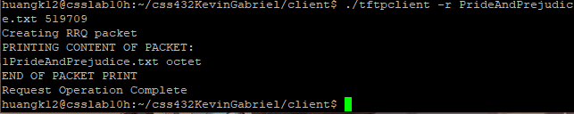

Client 2 (WRQ):

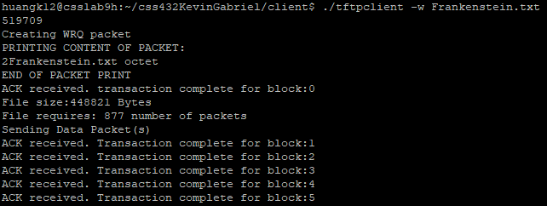

*Screenshots for blocks 6 – 874 not provided *

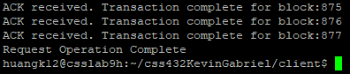

## Additional test cases: